Assignment 1

Images

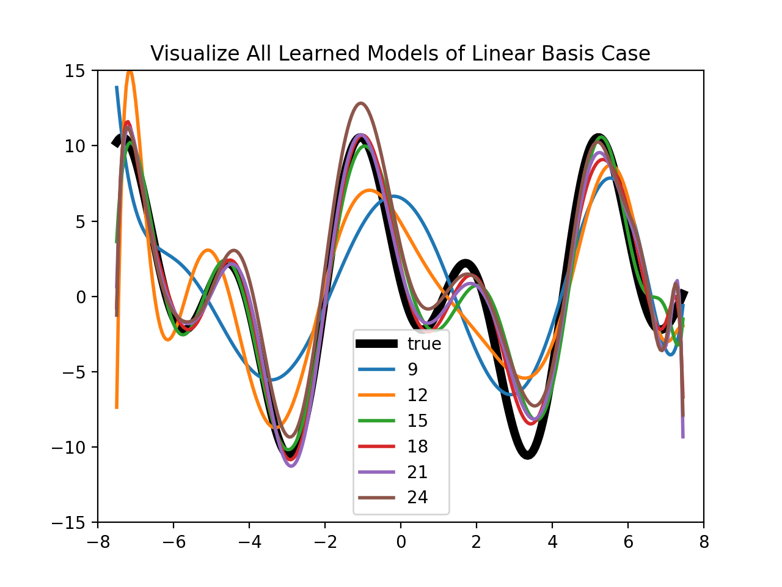

P.S.

I write the following document to simply discuss the non-programming part of Assignment 1.

I also add the pictures required with some comments.

With numpy.random module, I got a set of data points randomly distributed around the true function.

Then, I used train_test_split in sklearn.model_selectioon to split the data points into Training set, Validation set and Test set.

**1. ** Regression with Polynomial Basis Functions\*\***

a) Completed in code.

b) Completed in code.

c) Completed in code.

d) Which choice of d do you expect will generalize best?

From the image above, d = 18 will get a lowest validation error. Actually, if we run the code some more times, we can get different images. But the lowest point is always around d = 18 which usually 15 if not 18. Below is another result I got.



**2. ** Regression with Radial Basis Functions\*\***

a) Completed in code.

b) Completed in code.

c) What are some ideal values of 𝛌?

From the image above, 𝛌 = 0.001 will be a good choice. I compressed the 𝛌 axis logarithmically to get a more intuitive vision. The Validation Error will decrease while 𝛌 decreases. So I would guess we can get lower Validation Error if we use a smaller 𝛌. Even though this may cause huge calculation workload. It can be seen that 𝛌 and Validation Error are basically in a logarithmic relationship.

d) How does the linearity of the model change with 𝛌?

While the 𝛌 decreases, the models tend to be more and more nonlinear. At the same time, the models tend to be more and more close to true function.